Databases Assignment

Logical ERD

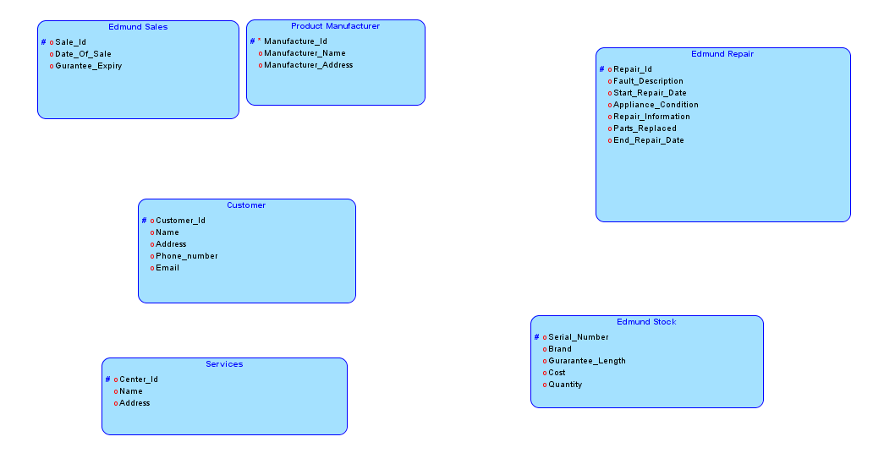

ERD script
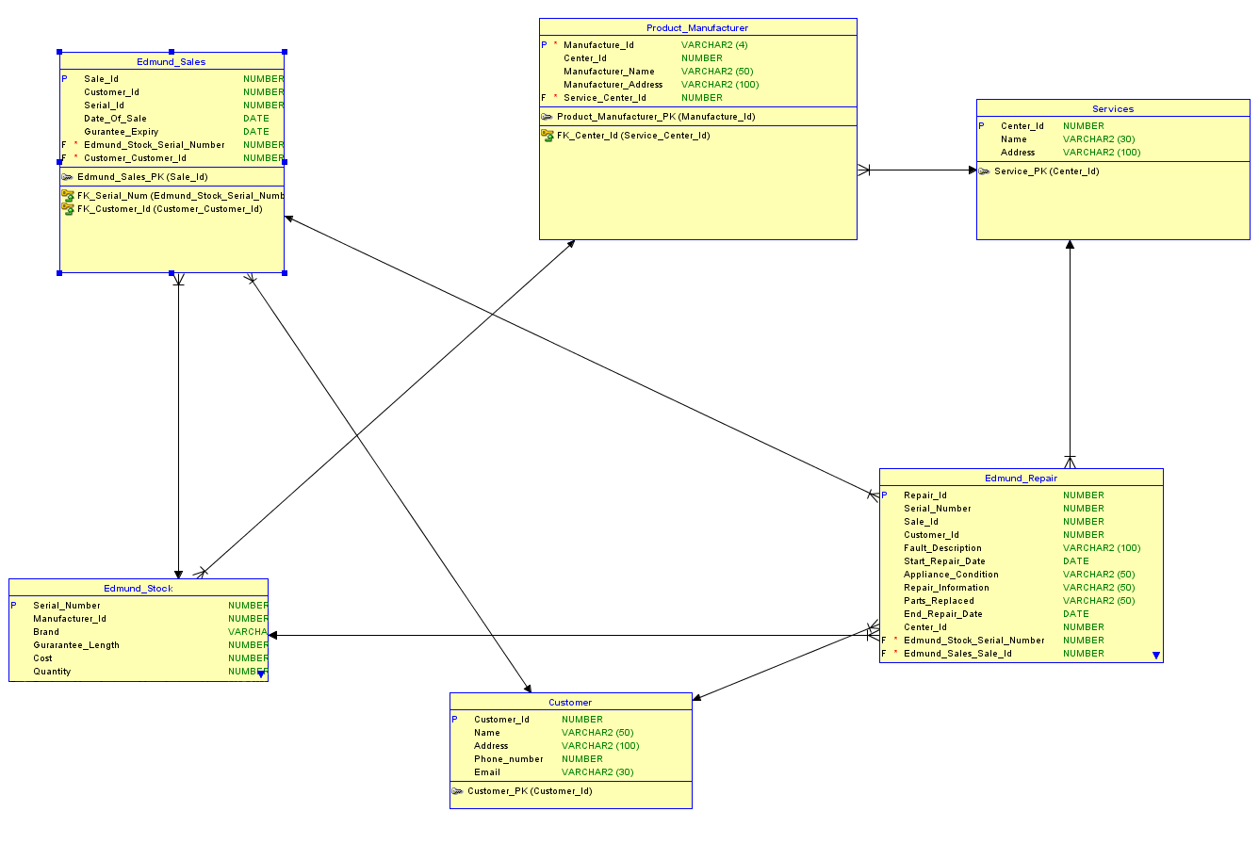

I Started the assignment dividing each section of the case study to figure out what sections needed to be in each other, This then led me to establish names for each of the variables (names) of the script, I also needed to figure out which ones are the primary/foreign keys to match all the Script together which in term made the ERD work amongst itself.

